Installing and Using the jsp101 system with word
Automatic installation
Security Settings

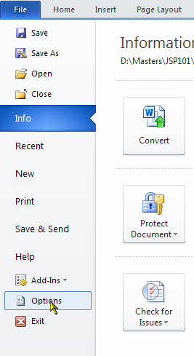
The automatic installation should work on most systems, but macro security may need changing to allow this to take place. The installation routine is written as a visual basic program within a Word document which means that for installation to work, Word has to be told to allow macros to run.

The settings can be found in the Trust Center in Word and this can be accessed via the ‘File’ tab - ‘Options’.

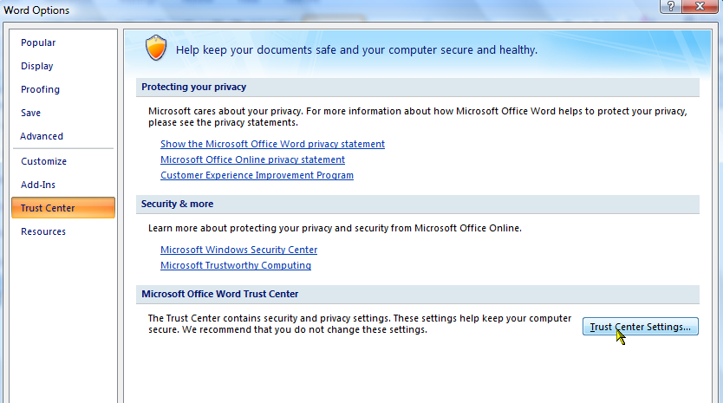
The Options dialog is shown on the right, with the ‘Trust Center’ second from bottom. To access the settings, click the ‘Trust Center Settings’ button as shown.

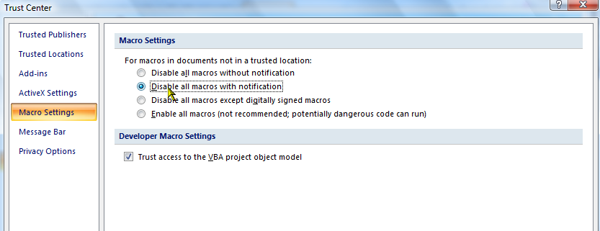

Choose the ‘Macro Settings’ option which gives the dialog shown on the left.

To install the JSP101 system, either choose ‘Enable all macros …’ which will allow all macros to run unchallenged – make sure you change this after the system is installed – or choose ‘Disable all macros with notification’ which will display a security bar at the top of the screen under the ribbon when a document containing macros (Visual Basic code) is opened. This second setting is probably quite a good general purpose setting to have anyway, unless you automatically want to disable all macros.

Now you can install the jsp101 system and if you have set the second option above, you may get Security Warning bar below the ribbon. Click ‘Enable Macros’ (or similar wording) to allow macros to run. When installation is complete, reset the macro settings if required.
Installation Procedure

The automatic installation can be achieved from either the self-extracting executable program JSP101-V7.x.EXE or from the zip archive JSP101-V7.x.ZIP (x will be the build number). All the system files are contained in both.

Running the .exe Version. If you are happy and able to run the .exe version, then everything will happen automatically. NOTE – some anti-virus programs may not let you run this or disrupt the installation process (Avast is one with reported issues) and if this is the case you may be better using the .zip version as described below.

Run the program from the disk/folder where it has been downloaded. There will be several information dialogs to inform you of what is happening including where the installation files should be extracted to and the default location for the files is My Documents\~JSPTEMP, but if this is not convenient, simply change this or browse for a different folder. It is recommended that you specify a new folder because all the temporary files will be deleted at the end of installation.

Click through the dialogs and the files will be extracted. The Word document ‘JSPSETUP.DOCM’ will then be opened which contains the installation routines for your computer. When it loads, you may get the security warning (unless you have set the macro security to the lowest level) so make sure you choose ‘Enable this Content’ (or similar wording) from the security warning bar otherwise the installation will not work!

When the document opens it briefly explains what it does, so click ‘Install Template’ and the system will be installed with all files put into the correct folders (as described below). Word will then close.

Using the .zip Version. If you would rather use the .zip version, download it and unpack all files to a folder of your choice – a new empty folder is probably the best.

Find and open the file ‘JSPSETUP.DOCM’ which contains the installation routines and when it loads, you may get the security warning (unless you have set the macro security to the lowest level) so make sure you choose ‘Enable Macros’ (or similar wording) from the security warning bar otherwise the installation will not work!

When the document opens it briefly explains what it does, so click ‘Install Template’ and the system will be installed with all files put into the correct folders (as described below). Word will then close.

If you are upgrading from a very old version of the JSP101 system, this will be detected and you will have the option of deleting the old files. If you choose ‘No’ (i.e. not to delete) then all the old files will be moved to a folder called ‘oldversion’ which will be created under the JSP101 system folder which is usually found in My Documents.
manual installation

Download the .ZIP version of the system from the website and extract the files to a folder which can be where you like, but a new empty one is suggested. All the files you need are now there and you must manually install the system as follows:

Copy ‘jsp101.dotm’ directly to the Word User Templates folder.

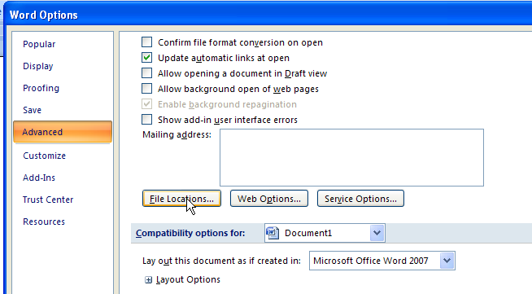
Copy ‘jspglobal.dotm’ directly to the Word Startup folder.

These locations can be found in the Advanced section of the ‘Word Options’ system accessed via the ‘File’ tab/’Options’ in Word 2010 or later or for Word 2007, click the top Office Button and then ‘Word Options’ is on the bottom right.

The Options dialog is shown here, with the ‘Advanced’ section selected. To access the ‘File Locations’ settings, scroll down through all the possible settings to the bottom of the list and find the ‘File Locations …’ button.

Click this button and the locations of all the user definable folders are displayed. The 2 folders that you will need for manual installation are shown below, namely the ‘User Templates’ folder and the ‘ Startup’ folder. A long path name will not all be visible, so select the entry and click ‘Modify’ (or double click) and you will then be able to get to the full path.
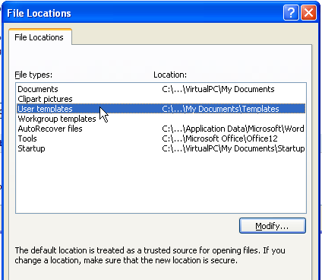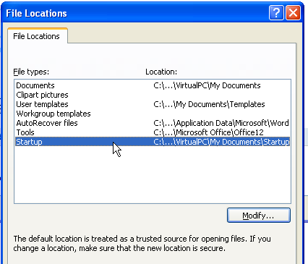

Now create a folder called 'JSP101' under 'My Documents'. You can actually create the folder anywhere you wish, but when you run the system you will be asked to show where the files have been put if the JSP101 system can't find them!

Copy the following files to this new folder:

jspletterbody.dotx jspminutesbody.dotx

jspnotebody.dotx jspbriefbody.dotx

jspsubmissionbody.dotx jspagendabody.dotx

jspplainbody.dotx

Installation and Use in Word.docx

Help Manual.docx

The file called ‘jspsetup.docm’ can be ignored because it is there simply to handle the automatic installation.

The system is then ready for use.

Under the automatic .exe installation the temporary files will be deleted, but if you have done an entirely manual version it is recommended that you delete the temporary folder and the files.

You will need to edit the document templates to personalise them for your use - address, logos etc. This is covered in full in the on-line help manual.
USING THE JSP101 SYSTEM UNDER WORD

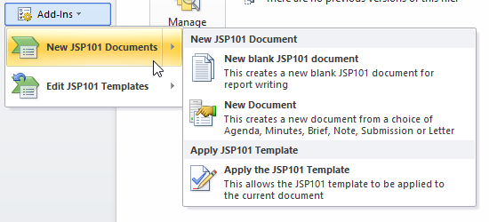
In Word 2010 and later, the Office Button has been replaced by a ‘File’ tab and the JSP101 options of New JSP101 Documents and Edit JSP101 Templates appear under the ‘Add-Ins’ section. [If you still using 2007 then these options appear when you click the Office Button]

Three new document options are available – ‘New Blank JSP101 Document’, ‘New Document’, or ‘Apply the JSP101 Template’.

The top option will simply open a new blank document with the JSP101 functions available for writing a report for example. The 'New Document' option displays a dialog where one of the document templates can be chosen to create a new document - Agenda, Minutes, Brief, Note, Submission or Letter. The final option on the menu is ‘Apply JSP101 Template’ which allows you to add the system functionality to an existing document that has been created elsewhere, although it won’t automatically change all the paragraphs!

You will now have a new document with the JSP101 functionality and there will be a new tab on the ribbon called ‘JSP101’ which will be at the left end after the ‘File’ tab. This contains all the functions as shown below.

All the main functions are shown with their own buttons with the exception of those that are more rarely used, which can be found in the Misc group on the right by clicking the ‘Other Functions’ button. One of these gives you the ability to check whether there is a new version of the system available and download and install it.

The full help manual will have been installed in the JSP101 installation folder called
‘Help Manual.docx’.

To open the manual, click the ‘On-line Manual’ button in the Help group or use the hot-key Alt+O. The manual is also available from some dialogs via a help button.

If you are a new user, have a look at the first 3 sections under Introduction which will give you a good idea how the system works and will explain the JSP101 ribbon and the Keyboard Shortcut keys. Also have a look at the section under Hints and Tips about General Use. There is also a full section about using and editing the document templates.

One of the most useful features while writing your document is the use of the Tab and Enter keys.

The system 'understands' what level of numbered paragraph you are currently in and detects that the TAB or ENTER key has been pressed at an empty paragraph. If TAB is used on an empty paragraph, the next lower level of numbering is automatically set; if ENTER is used the next higher level is automatically set.

To explain this, assume you are entering text at sub-paragraph c. to paragraph 6. and on pressing ENTER you get sub-paragraph d. automatically as shown below.

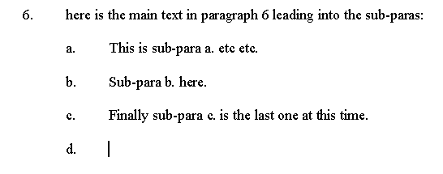

Here sub-paragraph d. is an 'empty' numbered paragraph – there is no text in it – so if TAB is pressed, the next lower level of numbering will be automatically selected – in this case sub paragraph (1). If ENTER is pressed, the paragraph will automatically change to the next higher level with the appropriate number – in this case 7.. This works the same whatever level you are working on, but if ENTER is pressed at an empty top level paragraph, the numbering is turned off and the paragraph becomes a normal no numbered paragraph.

If TAB is pressed within a paragraph or where there is no paragraph numbering then a normal TAB is inserted.

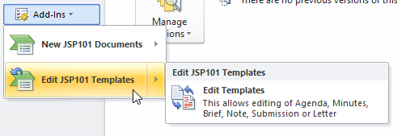
Editing the document templates themselves so that they can be personalised for your own unit logo, telephone number, signature block etc. is easily available via the other menu option added to the ‘File’ tab / ‘Add-Ins’ [on the Office Button menu in 2007] – ‘Edit JSP101 Templates’. Just be slightly careful what you change because these contain many bookmarks and controls that the JSP101 system uses to format these documents! It is suggested that the changes should be kept simply to name, rank, telephone number etc.
Any queries to the author Robin Lavies:

E-mail: robin@rlavies.co.uk
Updates from: http://www.rlavies.co.uk/jsp101.html

